Exam of Digital Communications
a.a. 2019-2020
Feb. 02, 2020

Exercise #1

The two pulses shown in the figure below are employed in a binary signaling
scheme to be used in a digital communication system with AWGN channel with noise energy N0/2.
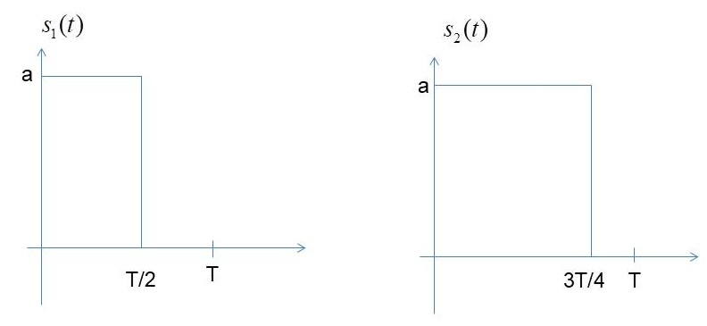

- Calculate the average energy per bit
- Sketch carefully the optimum receiver (and the impulse response of the filters are included in the receiver).
- Write the expression of the probability of error as a function of the energy per bit
- Compare the achieve probability of error with the probability of error of an antipodal binary transmission scheme with the same energy per bit

Exercise #2
A 4 kHz bandpass channel will transmit data at a rate of 9600bit/s. If N0/2=10^(-10) W/Hz is the spectral density of the additive zero-mean Gaussian noise in the channel, design a QAM modulation and determine the average power per bit that achieves a bit error probability of 10^(-4). Use a pulse with a raised-cosine spectrum having a roll-off factor of at least 50%.

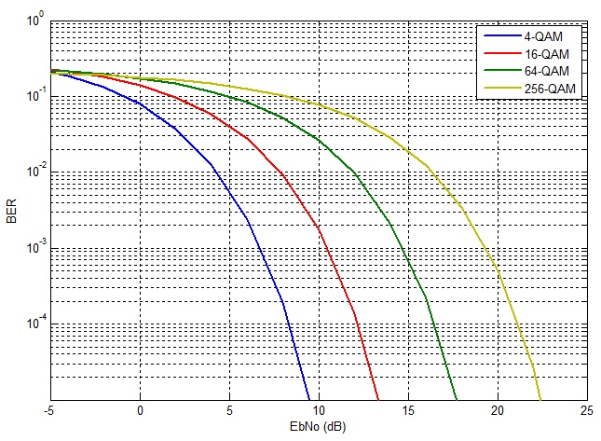

Exercise #3
In the design of a satellite geostationary link, what would you choose between an 8QAM or 8PSK constellation? Explain your answer.
If the previous link is designed for very high frequency bands (higher than 20GHz) in clear sky conditions. Given that the atmospheric precipitations cause signal degradation (lower SNR), to close the link when it rains, you have to use another modulation. Which one between QPSK and 16QAM? Explain your answer.

